Qian, Yu Ph.D
Visting professor UCLA
Professor
Department of Early Childhood Education
East China Normal University
Email:qianyu2007@163.com， 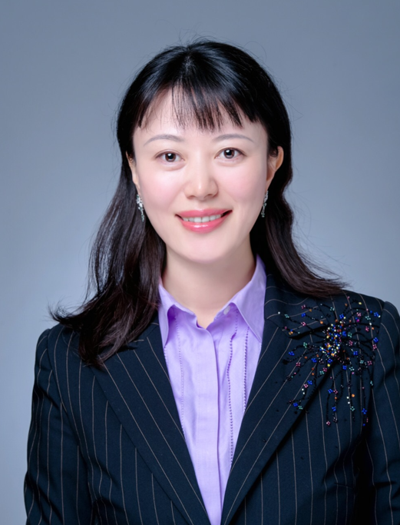

Yu Qian is a Professor in Early Childhood at East China Normal University, and visiting professor at UCLA. She is the Director of ECE Pedagogy Study office, government policy consulting advisor and the core expert in the Chinese ECE legislation. Her research interests lie in early childhood curriculum and pedagogy, educational policy and teacher education. She is the leading expert of Shanghai ECE legislation, drafted the ECE legal provisions for Shanghai Municipal Education Commission in 2023.
She is vice president of Family Education Committee and the board member of CNSECE, the official association of ECE China, guest researcher of Nanjing Normal University and guest prof. at Ni Xiang Normal University. She was the Deputy Secretary General of OMEP China. She has published more than 200 academic works including books, book chapters, and journal and conference​ papers. She has a high reputation in both academic and practical fields in China. She received Masters degrees at Nanjing Normal University and Ph.D. in Curriculum and Instruction at East China Normal University. She was a co-training doctoral student at Harvard University. She won ECNU Best Teaching Prize. She was a visiting scholar at UCLA in 2014/2015. She leads many projects for the National Planning Office of Philosophy and Social Science, China and Department of Education, China and Program of Humanities and Social Sciences of Ministry of Education, China. (ORCID:0000-0002-3779-660X)

